NOTICE OF HEARING

BEFORE THE CITY OF MISSION

PLANNING COMMISSION

Notice is hereby given that the Mission Planning Commission shall meet for the purpose of holding a Public Hearing to discuss and consider approval of proposed changes to the City’s regulations regarding signs. Proposed changes include but are not limited to the following.

AN ORDINANCE AMENDING SECTION 420.220 AND SECTION 430.130 OF THE LAND USE REGULATIONS OF THE MUNICIPAL CODE OF THE CITY OF MISSION.

SECTION 420.220 NON-CONFORMING SIGNS

A. Subject to the provisions of this Section and Section 420.200, non-conforming signs
that were otherwise lawful on the effective date of this Article may be continued.
B. No person may engage in any activity that causes an increase in the extent of
non-conformity of a non-conforming sign. Without limiting the generality of the foregoing, no non-conforming sign may be enlarged or altered in such a manner as to aggravate the non-conforming condition, nor may illumination be added to any non-conforming sign.

C. A non-conforming sign may not be moved or replaced and the message may not be
changed, except to bring the sign into complete conformity with this Article, and except for "sign maintenance" as defined in Section 430.020. In conducting "sign maintenance" to a non-conforming sign, a new sign permit is required.

D. Non-conforming signs may be maintained and repaired so long as the cost of such
work within any twelve-month period does not exceed fifty percent (50%) of the fair market value of such sign. No such work shall be done without the person proposing to do such work submits information reasonably required by the City to establish the cost of the work and the value of the sign.

E. If a non-conforming sign other than a billboard advertises a business, service,
commodity, accommodation, attraction or other enterprise or activity that is no longer operating or being offered or conducted, that sign shall be deemed abandoned and shall be removed (including support structure) by the sign owner, owner of the property where the sign is located or other person having control over such sign within thirty (30) days after such abandonment.

F. If a non-conforming billboard remains blank for a continuous period of one hundred
eighty (180) days, that billboard shall be deemed abandoned and shall, within thirty (30) days after such abandonment, be altered to comply with this Article or be removed by the sign owner, owner of the property where the sign is located or other person having control over such sign. For purposes of this Section, a sign is "blank" if:
1. It advertises a business, service, commodity, accommodation, attraction or
other enterprise or activity that is no longer operating or being offered or conducted; or
2. The advertising message it displays becomes illegible in part or whole; or
3. The advertising copy has been removed.

SECTION 430.130 SIGNS OF HISTORIC SIGNIFICANCE

A. Purpose. The signs of historic significance regulations are intended:

- To provide for the preservation of the City of Mission's unique character, history, and identity, as reflected in its historic and iconic signs;
- To preserve the sense of place that existed within the central business district and in areas of the City with concentrations of surviving historic signs;
- To protect the community from inappropriate reuse of nonconforming and/or illegal signs while ensuring that the signs are safe and well maintained;
- To allow the owner the flexibility to preserve historic and vintage signs. This classification does not preclude owners from removing these signs.

B. Criteria for identification of a sign of historic significance. A proposed sign of historic
significance shall comply with at least three (3) of the following criteria.

- The sign shall have been installed at least 40 years prior to the date of application;
- The sign is an example of technology, craftsmanship or design of the period when it was constructed;
- The sign may include, but is not limited to, a detached sign, pole sign, a roof sign, a painted building sign, or a sign integral to the building's design (fascia sign) or any other type of sign that was permitted on the property at the time the sign was installed;
- The sign is structurally safe or can be made safe without substantially altering its historical appearance; and
- The sign retains the majority of its character-defining features (materials, technologies, structure, colors, shapes, symbols, text and/or art) that have historical significance, are integral to the overall sign design, or convey historical or regional context.
- The sign exemplifies the cultural, economic, and historic heritage of the City;
- the sign is unique, was originally associated with a local business or local or regional chain, or it is a surviving example of a once common sign type that is no longer common.

C. Process for approval of signs of historic significance.

- Application for approval of signs of historic significance may be made by the property owner having control over a sign or may be initiated by the City.
- within 60 days of submittal of an application, the Planning Commission shall determine if the application is complete and if the sign meets the applicable criteria for classification, and shall notify the property owner in writing whether or not the sign is eligible for classification as a sign of historic significance.
- If the Planning Commission determines that the sign is not eligible for classification, the property owner may appeal the decision to the City Council within 30 days after such determination.

D. Exemptions, restoration, reuse.

- Signs classified as a sign of historic significance are exempt from the sign regulations regarding type, height, area, and location as set forth in the City Code.
- Signs of historic significance that are nonconforming as to type, size, height, or location are exempt from the regulations governing nonconforming signs and abandoned signs. However, changes to the sign may not increase the nonconformity unless a variance is granted by the Board of Zoning Appeals.
- A sign of historic significance that will be adaptively reused must retain, repair, or restore the majority of the character-defining features (e.g., materials, technologies, structure, colors, shapes, symbols, text, and/or artwork) that have historical significance, or are integral to the overall design of the sign, or convey historical or regional context.

E. Demolition of a sign of historic significance. Classification as a sign of historic
significance does not prevent the owner from demolishing the sign.

The hearing will take place on Tuesday, May 29, 2018 at 7:00 pm at Mission City Hall, 6090 Woodson St, Mission, Kansas, at which time all interested persons will be heard.

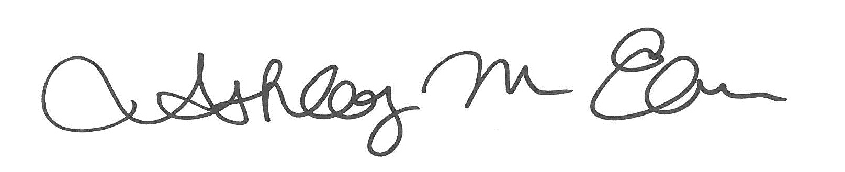
___________________________________
Ashley Elmore
Planning Commission Secretary

