STAFF REPORT
Planning Commission Meeting May 29, 2018

AGENDA ITEM NO.: 3

PROJECT NUMBER / TITLE: Application # 17-11 Tidal Wave Auto Wash Final Site Development Plan Review

REQUEST: Site Plan review for the redevelopment of the former gas station site into a car wash

LOCATION: 6501 Johnson Drive

PROPERTY OWNER: APPLICANT:
CStore Investors Too, LLC Steve Block
700 W 47th St, Ste 200 Block Real Estate Services, LLC
Kansas City, MO 700 W 47th Ste, Ste 200
Kansas City, MO

STAFF CONTACT: Brian Scott, Assistant City Administrator

ADVERTISEMENT: 3/6/2018-The Legal Record newspaper

PUBLIC HEARING: Planning Commission meeting 3/26/2018

Property Information and Background
The subject property is located at 6501 Johnson Drive and has been used as a gas station / convenience store for many years. The property is currently zoned “CP-2B” Planned Retail and Service District, but is also within the West Gateway Form Based Code (FBC) Overlay District.

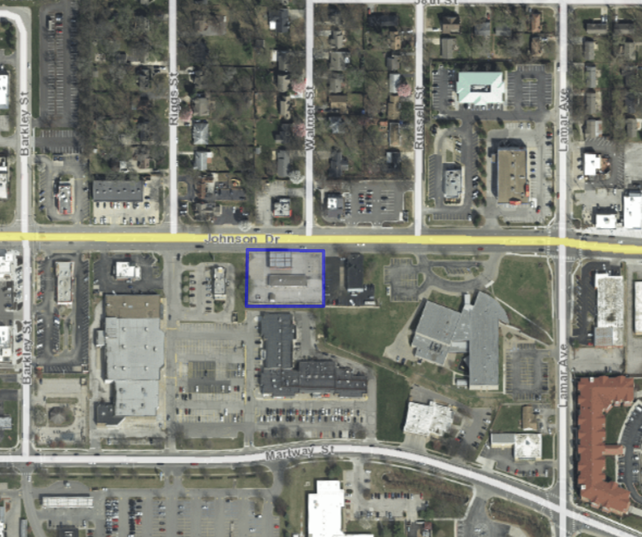
Figure 1: Subject Property-6501 Johnson Drive

The applicant, Mr. Steve Block, is a representative of the ownership group, CStore Investors Too,LLC of Kansas City, Missouri. They have a pending real estate contract to sell the property to Tidal Wave Auto Spa of Thomaston, Georgia. Upon purchase, Tidal Wave intends to demolish the existing structure(s) on site and develop a new, new automatic car wash tunnel and supporting services building totaling approximately 9,900 square feet. The proposed, new use is permitted with CP-2B zoned districts. However, because the property is within the West Gateway FBC Overlay District (identified as Block “Y” in the FBC), any new development would require conformance with the FBC.

Form Based Code
Sector & Regulating Plan
This property is subject to the Form Based Code (FBC) as provided for in the West Gateway Overlay District. It is located in the northern part of Block “Y” in the Martway Sector. The applicant and developer are not proposing to assemble any additional parcels into the project. In the event of a conflict between the provisions of the FBC and the City Code or Johnson Drive Design Guidelines, the FBC takes precedence.

Details from the current regulating plan for this entire block include the following:

- Contains a combination of small and large parcels, many with good visibility from Johnson Drive.
- Ground level retail uses are important facing Johnson Drive. Retail is required along the frontage facing Johnson Drive. Parking and service areas should be accommodated away from Johnson Drive.
- The entire block is large enough to accommodate structured parking which would be a good fit with the existing grade difference between Johnson Drive and Martway Street.
- The extension of Walmer Street to the south connecting with Martway Street would be required in conjunction with development of the western half of Block Z.
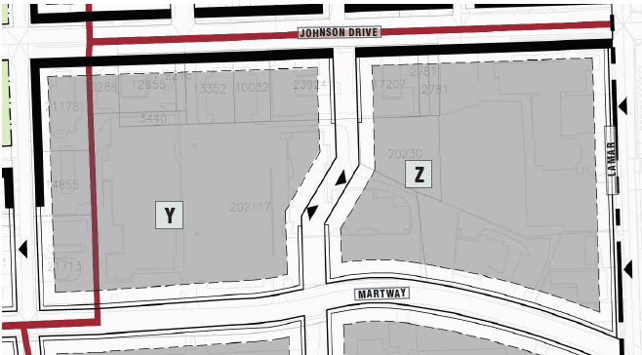

Building Types Allowed
The following building types are allowed:
Townhouse type requires a minimum of 2 stories and a maximum of 4. All floors to be residential.

Mid-rise building type requires a minimum of 2 stories and a maximum of 4. Ground floor office or retail and upper floor office, retail or residential uses are permitted.

Parking Structure building type has no minimum or maximum floors. Ground floor commercial or office is required at principal and secondary frontages.

Low-rise building types are allowed in any sector of the FBC, provided the site under development is no larger than ½ acre. This particular site exceeds ½ acre, but is less than 3 acres and would qualify for up to 60% of the gross square footage of development (in one or multiple buildings) to be Low-Rise building type. The applicant has chosen not to incorporate the extension of Walmer Street into their redevelopment plans. Such a street dedication may have reduced the area of this parcel to below the½ acre threshold.

Zoning of Surrounding Properties
North-”C-0” Office Building District, ”C-1” Restricted Business District, “C2-B” Retail & Service District. Free standing medical office, fast food and coffee shop with drive-thru service.
East-”C-2B”, Retail & Service District. Free standing auto repair shop.
South-“C2-A” Pedestrian Oriented Business District. Medical office, motor vehicle office, restaurant, fitness centers, discount stores and specialty retail located in a shopping center.
West-”C-2B”, Retail & Service District. Free standing fast food restaurant.

Comprehensive Plan Future Land Use Recommendation
The future land-use map of the Comprehensive Plan designates the area as appropriate for mixed-use medium density re-development to include a pedestrian-friendly mix of housing, limited office and medium density retail to serve the residents of the surrounding neighborhood. It should serve as a transition zone between low to moderate density residential areas and higher intensity development.

Form Based Code & Plan Review
The West Gateway Form Based Code is a tool that assists in determining the appropriateness of development submittals to the City of Mission. Findings by Staff are determined using the scoring system contained in the FBC. The Form Based Code is structured hierarchically, understanding that certain elements are mandatory prerequisites, others are significant and others are minor. During the building of the Code, it was reinforced that, in order to achieve the level of quality in the urban environment that was envisioned from the vision plan process, more attention should be paid to those elements that directly contribute to the public realm than to the individual elements of architectural design.

Therefore, the review process is also structured hierarchically, so that major elements are reviewed first. This allows Staff and the City’s consultants to provide the applicants with an opportunity to correct major flaws. Similarly, the early stages of review, including block configuration and building type, are more heavily weighted in the scoring process as they focus on elements that the Code regards as inviolate or of significant importance. Conversely, lesser items may yield a lower score but not result in a finding for disapproval. All of the elements are important, but have different values to the public realm.

The threshold score for a recommendation of approval by staff as established by the FBC scoring system is 90 points or more, of a possible 100 points including the prerequisite passing scores in steps 1 and 2. Proposals which achieve this score should be considered to be in compliance with the intent of the FBC. They proceed on under the review steps outlined in the FBC. Development submittals which achieve a score of 89 points or lower will proceed through the approval process of the zoning code including full design review by the Planning Commission and City Council.

Form Based Code review was conducted by the City’s master developer and Staff. This application receives a score of 60 points and fails several critical prerequisite steps. This is largely due to all of the proposed buildings failing to meet the required building type standards. Buildings either failed to meet the minimum heights or were designed in a way that failed to reasonably accommodate the required building features. Additional points were lost as the applicant did not provide sufficient landscape, streetscape, or accessory structure information for review. Please see the attached letter from Core Design for additional details of this review.

The proposed development includes two buildings. One building is a two story, 6,699 square foot building fronting Johnson Drive to the north side of the property. The other is a 3,200 square foot building containing an automatic car wash tunnel along the south side of the property. The ground floor of the north building would consist of a series of drive-in parking stalls with vacuums for use by car wash customers. A small office would be on the second level and serve as the regional office and training facility for the company. The applicant has indicated that the depth of the north building is sufficient for use as retail space in the future if the proposed use as a car wash facility ceases.

Exterior building materials include split face block, stone veneer, standing seam metal, EIFS, metal awnings, and glass. Heavier materials such as block and brick are generally placed lower on the building walls. Partial information about percentages of EIFS and storefront glazing was provided. Windows and doors do not meet the minimum 60% requirement for storefronts in the north building along Johnson Drive. EIFs is used on 45% of the ground and upper floor of the north building. Dumpster, retaining wall, pay canopy and pay kiosk details were not provided in the initial review.

The development would utilize a surface parking lot located on the interior of the lot and accessed by two private driveways. A drive through lane for the wash tunnel is shown along the south side of the property. All traffic would enter the site via the easternmost driveway and exit to the west. The existing median on Johnson Drive will be altered to allow inbound and outbound turning movements. A median break is also shown after the payment kiosk to allow traffic to bypass the wash tunnel and enter the rest of the site.

The City’s traffic engineer, GBA, has reviewed the site access plans, vehicle queues, turning templates, sidewalks, and traffic study and are generally satisfied with the design. GBA does recommend moving the median break to the west edge of the eastern drive entrance to allow vehicles to leave the wash tunnel queue before the pay station.

A landscape plan detailing streetscape improvements was not submitted with the initial review. The civil sheets generally show a sidewalk area meeting the FBC designs of 5’ sidewalks with a 4’ tree zones. Details of street trees and street furnishings like street lights, benches, trash receptacles and bike racks were not provided for initial review. All required streetscape improvements shall be installed within the existing or proposed right-of-way. Final placement and configuration of these elements (street and pedestrian lighting system, site furnishings, trees, sidewalk paving, etc.) must be further coordinated with and approved by staff at the time of public improvement construction plans.

Storm water drainage is gradually west across the site. The proposed redevelopment would reduce the overall impervious surface area by 5%. Therefore, according to city ordinances, stormwater detention and BMP treatment are not required.

The Sustainability Commission has not yet reviewed this proposal for compliance with the Sustainability Scorecard tool. The scorecard contains a set of criteria intended to gauge the sustainability of new developments in Mission. It takes into account such factors as building materials, energy and water conservation, walkability, and light pollution. The score is then passed along to the City Council to help inform decisions about city incentives.

No development incentives are being requested by the applicant.

The project as submitted failed to receive a passing score in the FBC review as described above. Major flaws such as building types needed be addressed further and minor supporting details were not provided for review. Therefore, Staff recommended to the Planning Commission that recommend denial of the Preliminary and Final Site Development Plan Case # 17-11 for the Tidal Wave Auto Wash project.

Decision of The Planning Commission and City Council
An incentive for compliance with the FBC is that development projects can be sped through the development review process at a much quicker rate. Proposals which achieve a score of 90 or greater can be considered to be approved at the initial Preliminary Site Development plan review and do not require further design review by the Planning Commission (Final Site Development Plan Review) as would be the case with other development projects. The Planning Commission holds the authority for review and approval of form based code site plan applications. Those that do not receive a score of 90 or higher would be required to go through Final Site Development plan review. As with all Preliminary Site Development Plan Review, the City Council has final authority for review and approval.

The Planning Commission conducted a public hearing on March 26, 2018. At that time testimony from the City’s Staff, the City’s planning consultant for FBC, the applicant, and members of the public was taken. After due deliberations the Planning Commission voted 8-0 to accept that all of the required findings of fact as stipulated in the Staff’s report would be met through compliance with the outlined below conditions, and therefore recommended approval of the development application.

The City Council meet in regular session on April 18, 2018 and voted 7-1 to uphold the decision of the Planning Commission.

Conditions to Be Met for Final Site Development Plan Review
The applicant has submitted materials for consideration of the Final Site Development Plan Review. Staff has reviewed the materials for conformance with the following conditions that were stipulated in the initial review and approval on March 26th. Staff’s comments are in italics under each condition.

- Complete information about percentages of EIFS and storefront glazing are to be provided for staff review and approval.

Approximate percentages of material coverings are summarized in the table below. Staff is satisfied that these meet the intent of the FBC.

North Building - Along Johnson Drive

Type of Finish | North | South | East | West
EIFS | 8% | 72% | 32% | 49%
Glazing | 61% | 20% | 0% | 13%
Stone Veneer | 26% | 6% | 54% | 27%
Split Face Block | 5% | 2% | 14% | 11%

South Building - Back of Property

Type of Finish | North | South | East | West
EIFS | 39% | 0% | 23% | 23%
Glazing | 27% | 67% | 17% | 17%
Stone Veneer | 15% | 22% | 35% | 35%
Split Face Block | 20% | 11% | 26% | 26%

- Along the Johnson Drive frontage, windows are doors shall meet the minimum 60% total coverage of the storefront and EIFs or stucco shall not be used within 8’ of the ground nor comprise more than 25% of the first story.

Plans indicate that the Johnson Drive Frontage of the proposed building will have 61% glazing (storefront windows). EIFS will only be 8% and is located along the top of the wall and parapet (or partial wall) at either end of the building. Stone veneer in a style known as “Southern Ledgestone” will be predominate on the front facade of the building. Split face block in an “Old Castle” style will go up the facade of the building
Approximately, two feet from the ground on the front facade of the building.

- Complete information regarding trash enclosures, retaining walls, other screening, pay canopy and pay kiosk in compliance with the Form Based Code standards shall be provided for staff review and approval.

Information has been provided detailing trash enclosure, canopy, and pay kiosk. This information shows that material and style are in conformance with the FBC.

- Complete details regarding the site landscape and public streetscape including street lights, benches, trash receptacles and bike racks in compliance with the Form Based Code standards shall be provided to staff for review and approval.

A landscape plan (sheet C-09) has been submitted indicating Shantung Maple, Velvet Pillar, and Everclear Laceback Elm to be planted along the front of the building on Johnson Drive. Each tree will be 2” caliber. Trees will be planted every 30 feet. Plans also indicate that tree grates will be incorporated into the sidewalk around each tree. Plantings through the rest of the site include Boxwood, Hooks Juniper, Switch Grass, Dwarf European Viburnum, and Periwinkle. Ground cover includes tall fescue and river rock.

Plans also indicate that two trash receptacles (Black 36 gallon steelsites RB-36) will be incorporated into the streetscape along Johnson Drive as well as two bike loops (creative pipe inverted “U”). There will also be one black, metal bench (72 inches). Details (pictures or drawings of these items were not provided).

In addition, plans indicate the installation of a decorative style of street light to be installed along Johnson Drive, but there are no pictures or drawings provided. A photometric plan (sheet E1.2) has been provided showing more standard parking light fixtures around the site (nothing on Johnson Drive), but no information about candight is provided.

These later items will need to be confirmed and approved by staff at the time construction drawings are submitted to the City.

- The median break in eastern entrance driveway shall be relocated to allow vehicles to leave the wash tunnel queue before the pay station.

Site plan sheet C-02 indicates that a median break has been created (note hash marks) to allow vehicles to exit the queue for the wash tunnel prior to reaching the pay kiosk.

- Complete details regarding the circulation of trash and other service vehicles on site shall be provided for staff review and approval.

Site plan sheet C-02 also indicates circulation movements for trash pick-up. Developer has indicated that the truck will enter the western driveway and pull into the site and up to the trash enclosure. Once completed, the truck will leave through the eastern driveway.

- Applicant and Developer agree to install a median break along the west edge of the entry drive into the car wash facility that aligns with the westbound parking lot aisle.

See response to condition 5.

- Applicant and Developer consent to the Commission conditioning approval of the plan on compliance with such streetscape improvements, as are required by applicable City regulations and as set forth in the Form Based Code for the West Gateway Study Area, Chapter 6 (Landscape Architectural Guidelines, Type II-Urban Blvd).

See response to condition 4.

- Applicant and Developer consent to the Commission conditioning the approval of the Plan upon the conveyance of right of way for sidewalks and landscaping along the site’s Johnson Drive frontage in such dimensions as is required by City regulations and via conveyance language usually and customarily provided in similar circumstances by the City.

Site plans indicate appropriate setbacks for right-of-way for sidewalks and landscaping along the Johnson Drive frontage. These will be confirmed at the time detailed construction documents are submitted and corrections, if need be, made. Conveyance of right-of-way will take place through a separate mechanism and accepted by the City Council.

- Applicant and Developer will consent to meeting with the Sustainability Commission and implementing mutually acceptable recommendations. Applicant and Developer are convinced that Developer operates the most environmentally sound and sustainable car washes in the country with emphasis on recycling and water conservation.

Applicant and Developer have been in contact with the Staff liaison to the Sustainability Commission to discussion submission requirements and times for presentation.

- Applicant and Developer consent to the Commission making approval of the Plan conditioned on delivery of Architectural Plans, with corresponding calculations which shall provide that windows and doors shall meet the minimum 60% requirement of the Mid-Rise building’s northern face, in compliance with applicable City regulations and as set forth in the Form Based Code for the West Gateway Study Area, Chapter 5 (Architectural Guidelines).

This has been indicated as such in the plans submitted. Staff will ensure this is still the case when final plans are submitted.

- Applicants and Developer will consent to the Commission conditioning approval of the Plan on delivery of requisite landscape details.

See response to condition 4.

Additional Staff Comments

Though not specifically stated in the above conditions, it has been requested, and applicant and developer have stipulated to, the removing a portion of the traffic median in Johnson Drive so that the edge of the median aligns with the eastern edge of the east driveway. This will allow for west bound traffic on Johnson Drive to make a left turn in to the site. Evidence should be shown in writing that the applicant and developer have gained approval with the property owner to the east for use of a shared driveway at the east entrance to the property.

The applicant and developer are proposing only one sign on the proposed building. This is to be located on the front of the building to the left. The sign is in accordance with the requirements of the sign code in that it cannot be more than 10% of the entire front facade. No other signs are indicated on the plans.

Attachments

Item A - Street Rendering - 1
Item B - Street Rendering - 2
Item C - Tunnel Rendering
Item D - Elevations of North Building
Item E - Elevations of South Building (Car Wash Tunnel)
Item F - Side Sections of Each Building
Item G - Exterior Finishes
Item H - Accessory Buildings
Item I - Pay Canopy Detail
Item J - Pay Canopy Picture
Item K - Pre Canopy Detail
Item L - Site Grading Plan
Item M - Site Landscape Plan
Item N - Ste Photometric Plan
Item O - Site Circulation Plan

